Excel Assignment - 7

1. Using Insert Function, give examples of any function available in the

different dropdowns present in the function library. For example

AutoSum, Recently Used, Text, Date & Time, etc.

Ans: We can insert formulas by using the Excel INSERT FUNCTION option.

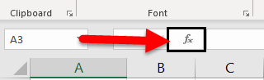

Click on this fx option to open the INSERT FUNCTION dialogue box.

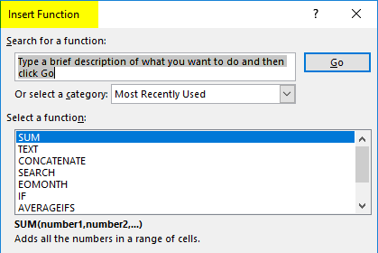

2. What are the different ways you can select columns and rows?

Ans:

* Select the letter at the top to select the entire column. Or click on any cell in the column and then press Ctrl + Space.
* Select the row number to select the entire row. Or click on any cell in the row and then press Shift + Space.
* To select non-adjacent rows or columns, hold Ctrl and select the row or column numbers.

3. What is AutoFit and why do we use it?

Ans: AutoFit is a feature in Excel that allows you to automatically resize cells in your spreadsheet. This can be useful if you have a lot of data that you need to fit into a small space or if you want to make sure all of your data is visible without having to scroll through the sheet.

To use AutoFit, simply select the cells you want to resize, then click on the “Home” tab and find the “Format” group. In this group, there will be a button labelled “AutoFit Column Width” – clicking this button will automatically resize the selected cells to fit the width of the data within them.

You can also use AutoFit to resize rows in your spreadsheet. To do this, select the cells you want to resize, then click on the “Home” tab and find the “Format” group. In this group, there will be a button labelled “AutoFit Row Height” – clicking this button will automatically resize the selected cells to fit the height of the data within them. AutoFit is a quick and easy way to make sure your data is properly sized in Excel spreadsheets.

4. How can you insert new rows and columns into the existing table?

Ans:

* Use the mini toolbar to add rows and columns

To open the mini toolbar, right-click in a table cell or tap in a selected table cell next to where you want to add a row or column. On the mini toolbar, click Insert and choose where you’d like to insert the row or column.

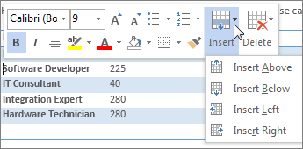

* Use Insert Controls to add rows and columns

Insert Controls work only with a mouse. If you’re using a touch device, use the mini toolbar, described above. Insert Controls appear outside your table when you move your cursor just above or to the left of two columns or rows. Click the Insert Control, and a new column or row will be inserted at that location.

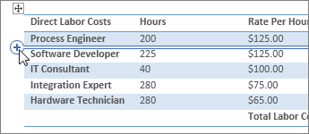

5. How do you hide and unhide columns in excel?

Ans:

* Hide a column: Select a cell in the column to hide, then press Ctrl+0. To unhide, select an adjacent column and press Ctrl+Shift+0.
* Hide a row: Select a cell in the row you want to hide, then press Ctrl+9. To unhide, select an adjacent column and press Ctrl+Shift+9.
* You can also use the right-click context menu and the format options on the Home tab to hide or unhide individual rows and columns.

6. Create an appropriate table within the worksheet and use different functions available in the AutoSum command.

Ans:

* Autosum

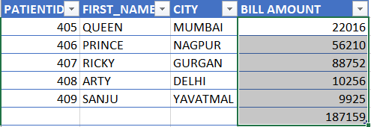

* Average

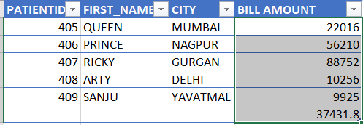

* Count numbers

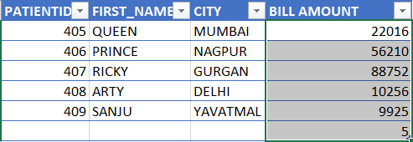

* Max

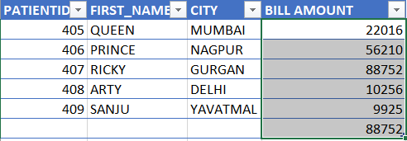

* Min

